1. Irregular Quad

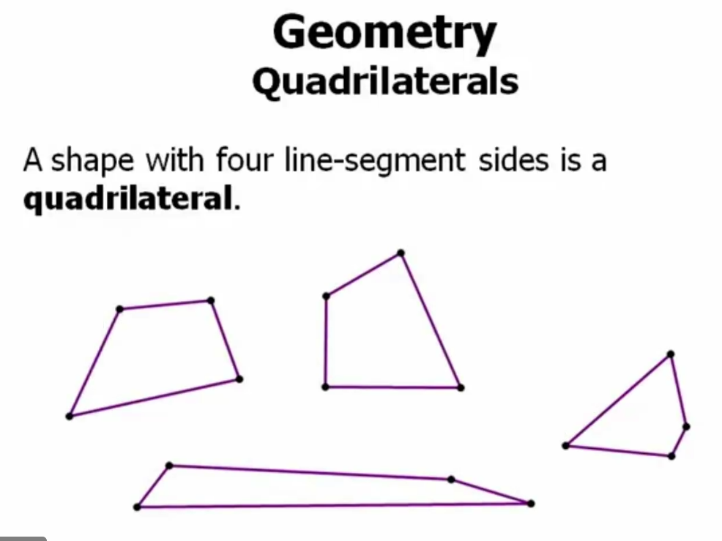

1. Common Quad

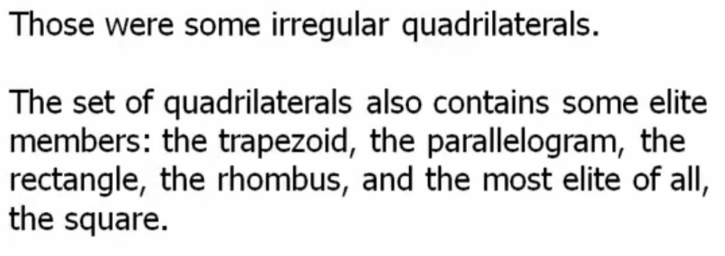

1. Quad rule of triangle

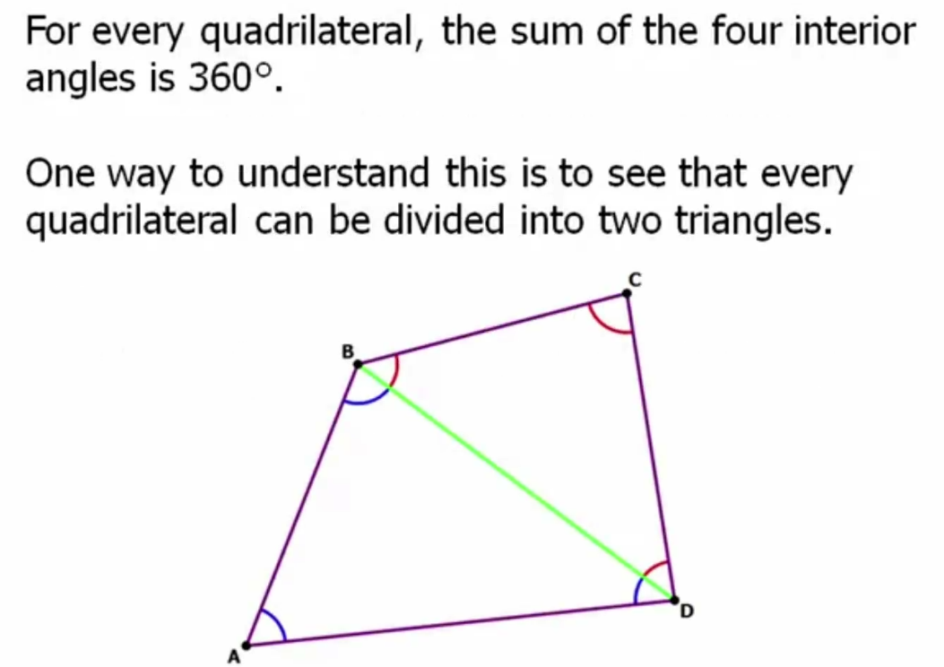

1. Diagonal

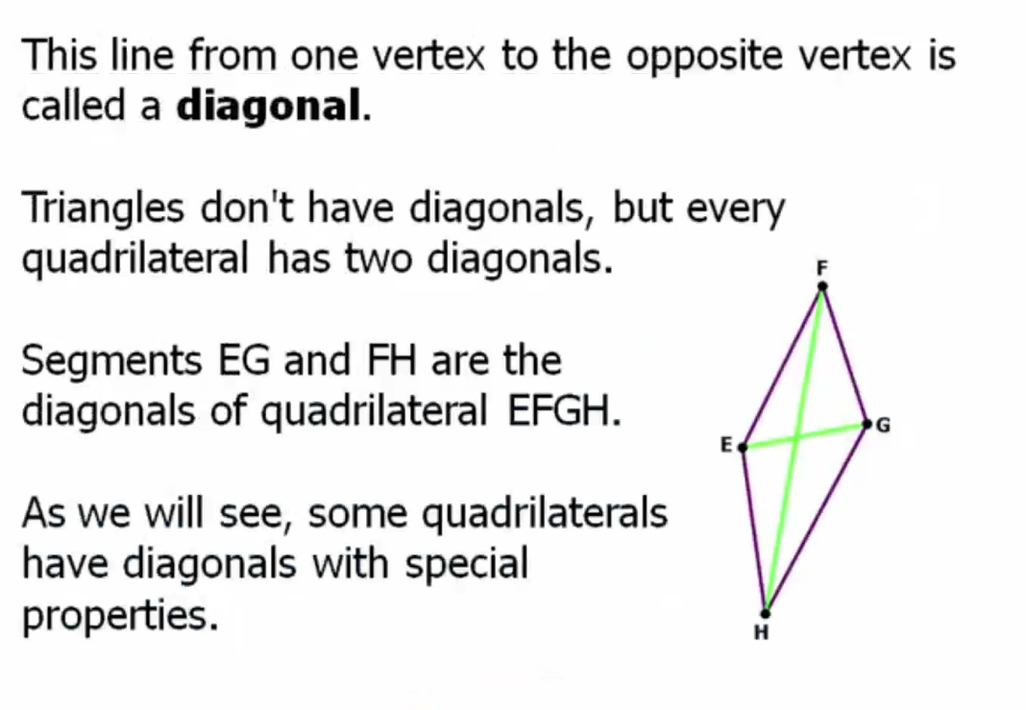

1. Parallelogram – Diagonals, Angles, Midpoints

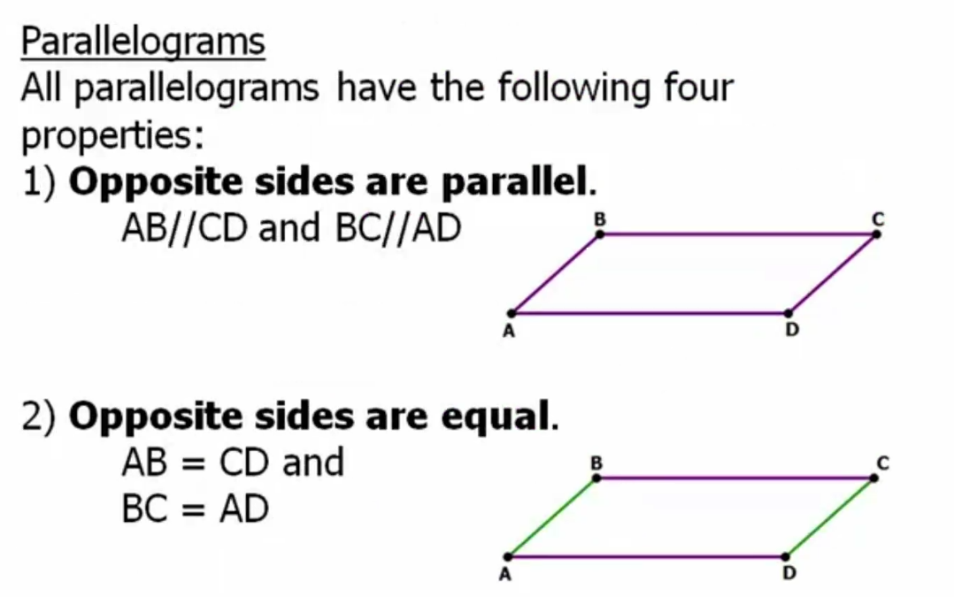

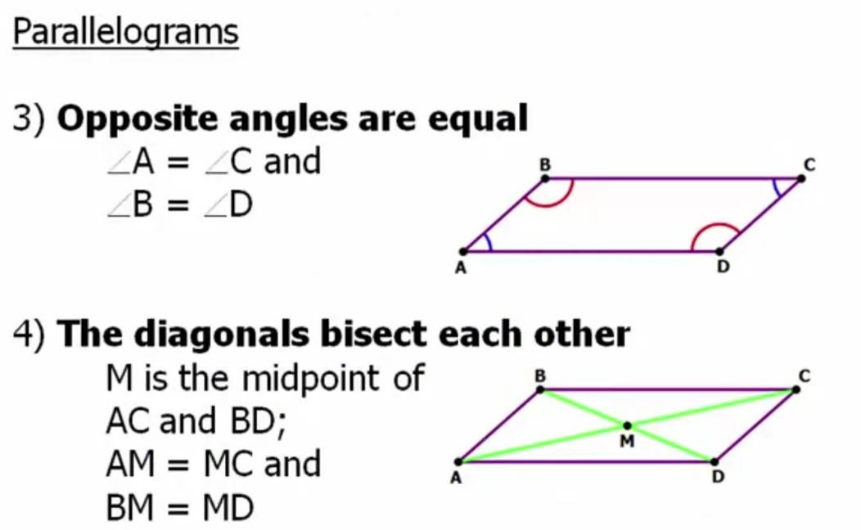

4 Rule

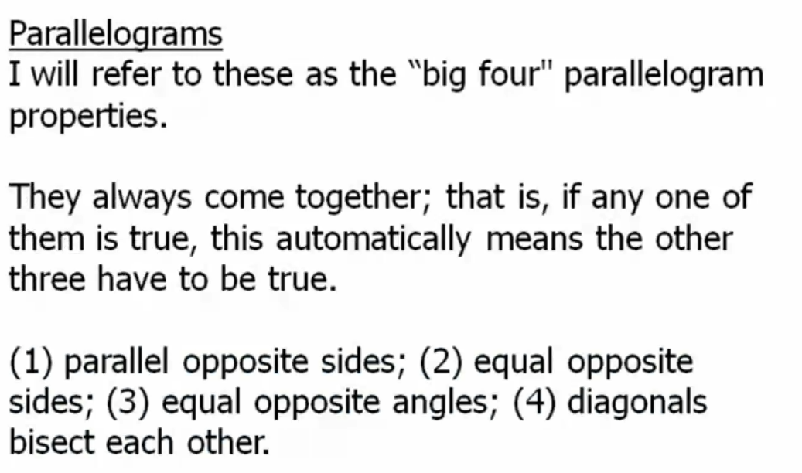

1. Rhombus – All sides are different

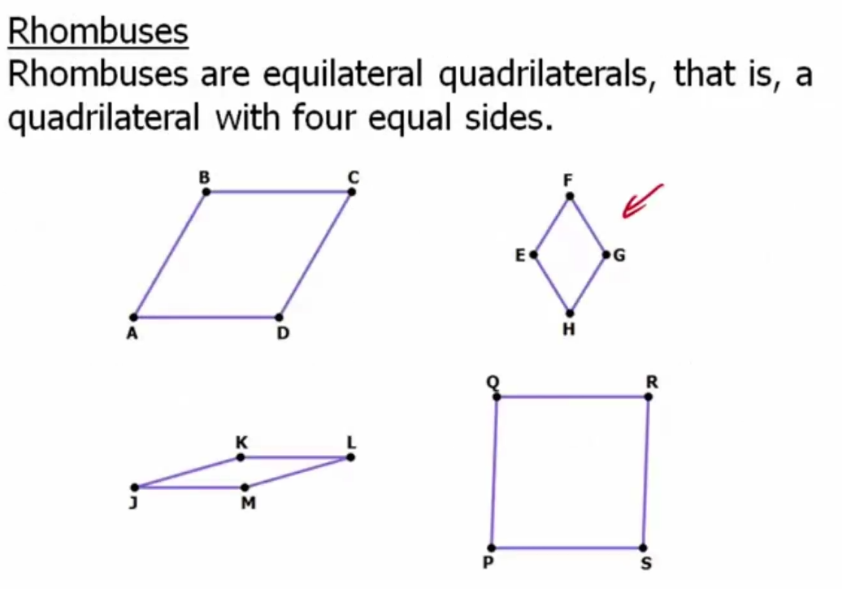

1. Rhombus diagonal midpoint vertex are 90 degree

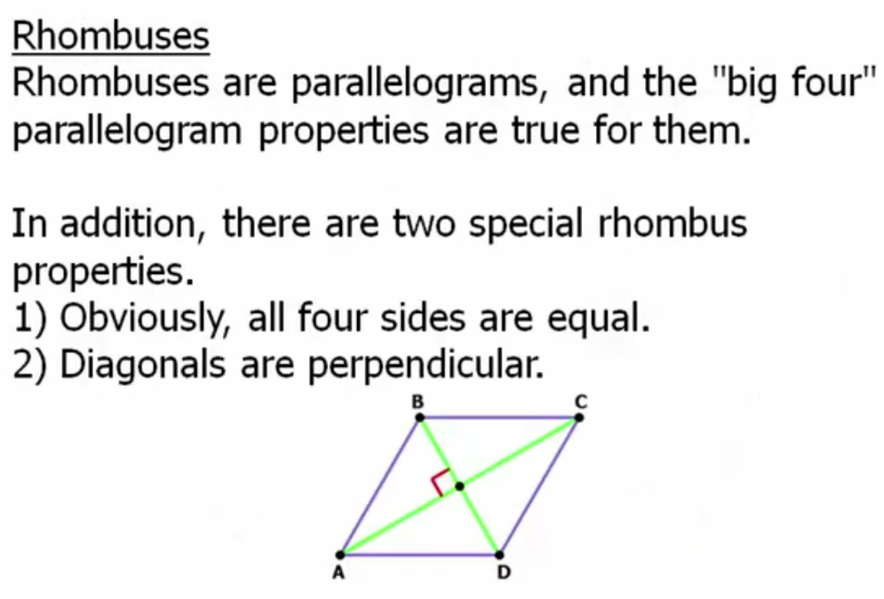8) Rectangle

1. Square

1. Problem

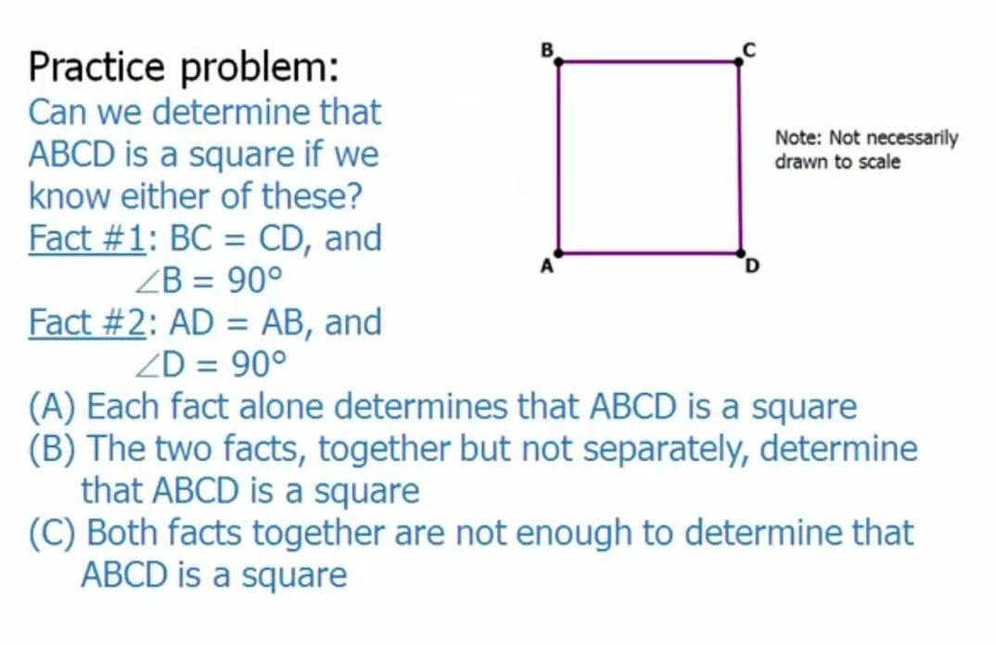

1. Trapezoid

Practice

1. Conceptual Relation

1. Summary

